CPS Phase II – Legging for the spread order

Overview

Current processing
None

New requirement
Strategy MKT order will split after the possible trades in CBOE into the individual derived leg orders as depicted in below diagram.

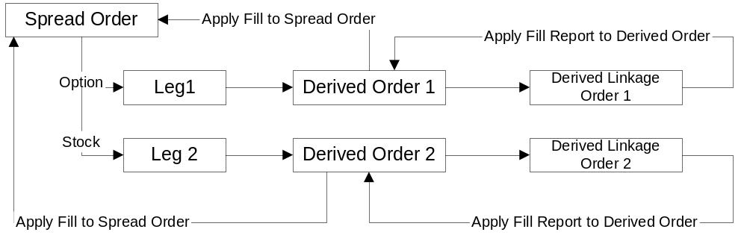

- Spread Order is split into individual derived split order.
- Derived leg orders behave as a regular MKT order, OHS will route it to linkage
- As the linkage responses of the linkage order are received, fills will be applied to the original derived order.
- Linkage order fill reports are published but nobody received it as system fake the user information of the linkage order.
- Once the original derived order received fill reports in ratio then it will apply fill report to the underlying spread Order.
- Once all leg quantities are satisfies then publishes the fill reports for Leg orders as well as spread order.

Required Trading Properties

New Trading Properties
- ‘CPS Ticks Hedged’ to configure a tradable trade-through price in CBSX
- ‘CPS Legging Minimum Available Stock NBBO Quantity’ to configure a size for Stock leg based on which a CPS MKT order
- ‘CPS Legging Minimum Option NBBO Bid Price’ to configure a bid price for Option leg based on which a CPS MKT order will be evaluated for legging
- ‘CPS Legging Max Stock Order Size’ to configure a maximum order size for stock leg that can be legged.
- ‘CPS Legging Max Option Order Size’ to configure a maximum order size for any of the option leg that can be legged.
- enableCpsMktLegging to toggle ON or OFF the new functionality being built for legging of a CPS MKT order which must be defaulted to ‘false’

Files Changed and Added

- TradingPropertyTypeImpl.java which provides the references and conversion between a Trading Property integer constant and the name.
private static final int cps_ticks_hedged = 1095;
private static final int cps_splitting_minimum_stock_nbbo_quantity= 1096;
private static final int cps_splitting_minimum_option_botr_bid = 1097;
private static final int cps_splitting_max_stock_order_size = 1098;
private static final int cps_splitting_max_option_order_size = 1099;
private static final int enable_cps_mkt_splitting = 1100;

- TradingPropertyFactoryImpl.java factory provides the conversion of PropertyGroup's to TradingPropertyGroup implementations
- TradingClassImpl.java cache for an application property
Helper method to print new-way defined trading property when invoked by pss to get the cached value
- TradingParameters.java For holding and managing trading properties for a trading class.

Below scripts are modified for the trading properties:
- setTradingProperty
- setTradingProperties
- getTradingProperty
- getTradingProperties
- addCPSSplitingHedgingTradingProperties
- TradingPropertyDefinitions.csv

Splitting Validation for CPS MKT Order:
We have added new helper class to have all the splitting validation in the HTS i.e.
SpreadOrderSplittingHelper

If the below conditions are satisfied then only we will assign different routing return reason code so OHS can send it to Splitting Service.

Below mentioned are the Splitting Conditions:

- If enableCpsMktLegging is True
- If the CPS order origin code is enabled for linking away in Auto Link Origin Codes
- If total NBBO qty is SAME or GREATER than the CPS Stock Legging Minimum available NBBO Quantity
- If Stock leg total quantity SAME or LESS than CPS Legging Max Stock Order Size
- On the Option leg if the NBBO Bid price is GREATER than or equal to CPS Legging Option Minimum NBBO Bid Price
- If Option leg total quantity SAME or LESS than CPS Legging Max Option Order Size
- If the system time is not within CPS Legging Time Before Close

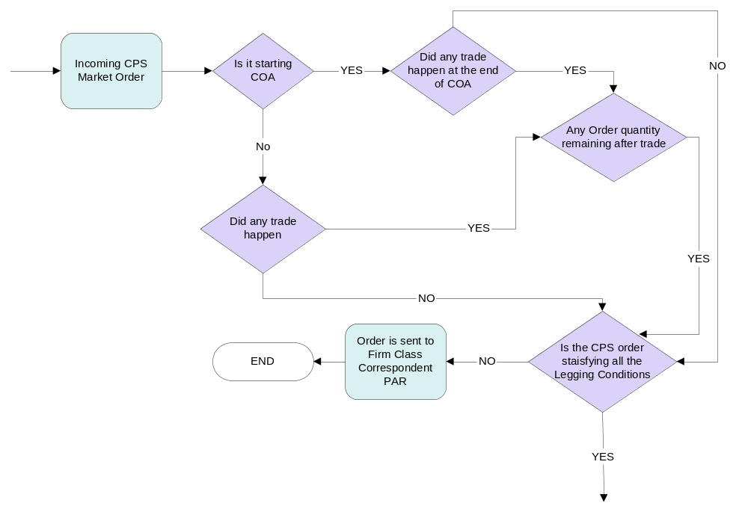

OHS Order Maintenance:
- Legging service splits spread order into the leg individual orders.
- Copy all the details from the spread order to derived leg order as is except following fields.
  - Product Key - Populated depending on based on session
  - Branch & Branch sequence number - Unique value is populated for this field which fetched from ID server / AutoLinkServiceImpl
  - Corresponding firm - This data is populated from either XML/setContext.main for derived orders.
  - User Id – Populated as space/ empty.
  - Session
  - Quantity

Mapping of the original spread order to derived orders are summarizes in the appendix.

- We have to create history event immediately after the split.
.
- To process stock leg derived order, OHS Hybrid will connect to OHS Equity using Routing Proxy and send OrderStruct to OrderHandlingServiceImpl.acceptOrder method.

- OHS Equity creates stock leg order from OrderStruct and returns Order Id to OHS Hybrid. OHS Hybrid Creates Option leg Order in OHS Hybrid.

- OHS Equity can throw the COM Failure for any reason such as
  - Unable to accept the derived spread order
  - Validation failed for derived order.
  - Unable to connect to OHS Equity
Then we should not auto link option leg and send whole package to PAR

- Once the fill report is obtained in the OHS Equity. Instead of publishing the fill report for individual order from OHS, return Fill report to OHS Hybrid by using routing proxy.

- Add new service to accept fill report of an individual derived leg order. This service will use ThreadPoolExecutor and return fill report to OHS Hybrid. This will avoid contention on the event channels.
- For some reason OHS Equity cannot apply FILL to original derived order in OHS Hybrid then just create the History event and send the Fill reject message to help desk.

Cancel and Cancel Replace for Legged Order:
If CPS Market Order is already split and linked by legging service then OHS should reject Cancel/Cancel replace request.
Currently OHS validate the cancel/cancel replace request for the order inside the OrderEntryServiceDelegateImpl class, which internally invokes CancelReplaceValidator methods to validate the cancel/cancel replace request. We can add one more method in CancelReplaceValidator class to verify whether order is legged or not, if it legged then OHS will reject the cancel/cancel replace request.

Add CancelReplaceValidator.isOrderLegged() method with the following validations-
- Check for Buy-write Market Order
- Invoke Legging service and check order existence in OrderRelationShip Cache. Or can verify one of the parameter from order that indicates order is legged.
If order is legged then generate the invalid request error message.
if(order.isCrossProductType()&& order. getPrice().isMarketPrice()){
if(order.isOrderSplitted){
MsgBuilder msg = msg().add("Can not Cancel CPS Market Orders")
.add("orderId", cancelRequest.orderId);
throw ExceptionBuilder.DataValidationException(msg.end(), NotAcceptedCodes.INVALID_REQUEST);
}
}

Legging Service :
Add a method in Legging service as isOrderSplitted(Orderorder)). This method validates order entry in OrderRelationShip cache (i.e. in cache maintaining relationship between leg orders and CPS order). Or check if the order is legged. We are using InternalExtensionFiels to pass the strategy product key, if the extension field has this strategy then it is legged order.

To Identify the Legged Order:

- To tag a CPS legging order, add a new String to InternalExtensionFields.java:
public static final String CPS_LEGGING_ORDER = "CPS_LEGGING_ORDER";

to tag the legging order:
ExtensionsHelper helper = getExtensionsHelper(leggingOrder.getExtensions());
helper.setValue(InternalExtensionFields.CPS_LEGGING_ORDER, CPS_MKT_ORDER_ID);

to retrieve the value:
ExtensionsHelper helper = new ExtensionsHelper(leggingOrder.getExtensions());
String cpsMKTOrderId = helper.getValue(InternalExtensionFields.CPS_LEGGING_ORDER);

Fill Report Handling for Legged Order:
Flow Diagram For Fill Report Handling:

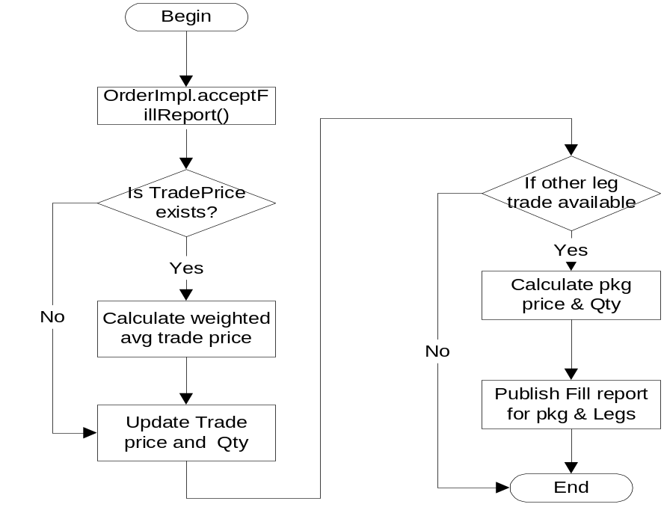

Package Fill Report Processing:
- Once leg order fill is received in Legging Service, check if leg trade price on the legged order exists, otherwise service will calculate the weighted average price for the legged order by using the below formula where weight = traded quantity and update it to Derived Leg Order.
if(legDerivedOrder.tradePrice != null && !legDerivedOrder.tradePrice. isNoPrice())
{
averagePrice =
(legDerivedOrder.tradePrice * legDerivedOrder.tradedQuantity) + (filledOrderPrice * filledOrderQuantity) /
(legDerivedOrder.tradedQuantity + filledOrderQuantity)

legDerivedOrder.tradePrice = averagePrice;
}

- Check if trade price exists on other derived Leg order, to calculate package price. If other leg has the sufficient quantity in ratio to satisfy the package quantity partially or fully then calculate the package level trading price considering leg trade prices and leg ratios as given below

SpreadTradePrice = (legSign*Equity leg average trade price * Equity leg ratio) /100 + (legSign * option leg average trade price * option leg ratio)

Where legSign is -1 for Buy Side and 1 for Sell side

Price strategyTradePrice ;
for(int i=0 ; i<noOfLegs ; i++)
{
if(leg[i].getProductType == ProductTypes.Equity)
legRatio = legRatio /100;
legTradePrice = leg[i].averagePrice * legRatio;
if (leg[i].side.isBuySide())
legTradePrice = -1 * legTradePrice;
strategyTradePrice += legTradePrice;
}

- As per the traded Quantity on both legs, legging service will decide how much quantity needs to publish for the package considering the leg ratios.
int overallTradedQty =0 ;
for(int i = 0 ;i <= noOfLegs; i++)
{ int tradedQty;
tradedQty=leg[i].getTradedQuantity()/leg[i].legRatio;
overallTradedQty=(overallTradedQty==0)?tradedQty:min(overallTradedQty, tradedQty)
}

- above fill report processing will take care of the all fill reports, if we haven’t received few fill reports within the timeout period then we will create the timeout message for the help desk users and keep strategy order in the cahce so later if any fill received before the cancel then we can apply fill report to the order

If (strategyOrder.getRemainingQuantity()> 0 && timeOutExpire())
{
generate the help desk message.
} else {
//This part executed if fill reports are already obtained for
whole linked quantity.
//REMOVE THE DERIVED LEG ORDERS FROM LEGGING CACHE.
}

OHS Equity ←→ OHS Hybrid Communication:
To send the equity order to OHS equity and receive the fill report from the OHS Equity, Routing Proxy communication (point-point) used, Equity Product route name information is already available in OHS hybrid.

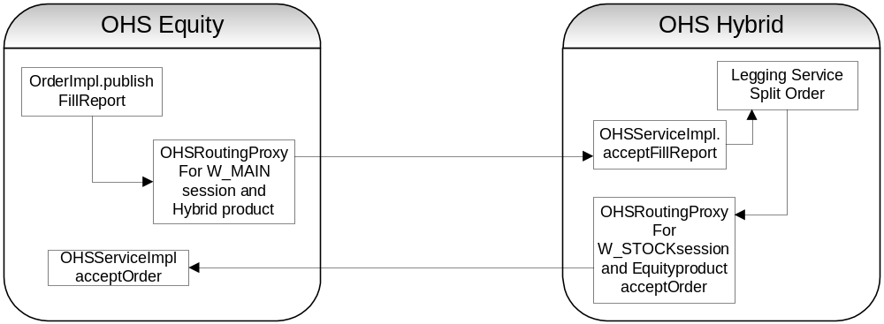

- Configure OrderHandlingServiceRoutingProxy home as follows in OHServer.xml to access OHS Equity/Hybrid via routing proxy.

<BOHome name="OrderHandlingServiceRoutingProxyHome">
<BOHomeProperties>
<homeImpl>com.cboe.proxy.businessServices.OrderHandlingServiceRoutingProxyHomeImpl</homeImpl>
<managedResourceName>OrderHandlingServiceRoutingProxyHomeImpl</managedResourceName>
<interceptorName>OrderHandlingServiceRoutingProxyInterceptor</interceptorName>
<interceptorImpl>com.cboe.proxy.businessServices.OrderHandlingServiceRoutingProxyInterceptor</interceptorImpl>
<roundTripTimeoutValue>&lt;prefixRTTValueOHS&gt;</roundTripTimeoutValue>
</BOHomeProperties>
</BOHome>

- Use BusinessServicesHelper to get handler of orderHandlingServiceRoutingProxy and call acceptOrder method of the OHS

- This intern uses BussinessServiceRoutingProxy.getServiceByProduct( productKey) method to get the service for route name fetched from ProductRoutingServiceImpl.getRouteNamesByProduct(productKey)

- ProductRoutingServiceImpl fetches the routeNames from ProductRoute cache that maintains routenames of all equity and option products.

- OHS always has the Option and equity product data, so we can easily figure out the OHSRoutingService and make the call.

- OrderImpl in OHSEquity will not publish fill report for the derived equity order and will give to OHSRoutingProxy of the Option ohs.

String sessionName = p_fillReports[0].sessionName;
OrderHandlingService service = (OrderHandlingService) getServiceByProduct(sessionName, p_productKey );
service.acceptFillReport(p_activityType,p_userId,p_fillReports,p_productKey);
}

- In OrderHandlingServiceImpl add method to accept the fill report from OHSEquity and give it to Legging service, which will process the package level fill report and publish the leg fill report to.
public void acceptFillReport(short p_activityType,
String userId, ManualFillStruct[] p_fillReports, int p_productKey) {
LeggingService.acceptFillReport(p_activityType,getOMTOrderRoutingParameterStruct(userId),p_fillReports);
}

- Add new thread to accept fill report of an individual derived leg order. This thread will be execute by ThreadPoolExecutor and return fill report to OHS Hybrid in this thread. This will avoid contention on the event channels.
final ExecutorService threadPoolForGroups;
threadPoolForGroups =
Executors.newFixedThreadPool(ThreadPoolSize);

threadPoolForGroups.execute(new ApplyFillReportThread(sessionName, p_activityType,p_userId,p_fillReports,p_productKey));

- Legging service in OHS hybrid will accept the fill report and apply it to the original order to generate the package level fill.

Timeout Message sending to HelpDesk:
To send the timeout message to help desk once timeout occurred for the order.
Timeout parameter will be populated from the XML as CPSLeggingTimeout.

Once the order is split then Splitting service will schedule the Timer on the TimerTask by passing the command

SplittedOrderExpirationTimerTask timerTask = new
SplittedOrderExpirationTimerTask(this, order);
new Timer().schedule(timerTask,cpsMktOrderTimerExpiration);

Once Timeout occurred the command will invoke the ProcessTimeout method which will verify whether order is fully traded or not, if it is still waiting for the Fill reports then it will send out the text message to help desk user by invoking the sendMessageToHelpDesk method.

spreadOrderSplittingService.processTimeout(order);

To send the actual text message we have to invoke the AdminTextMessageServiceHome,

OHS already has the routing proxy configured for the TextMessageService, we are using the same routing proxy to send the Text message to HelpDesk

@FFHomeDependency
public final void setAdminTextMessageServiceHome(AdminTextMessageServiceHome p_adminTextMessageServiceHome) {
adminTextMessageServiceHome = p_adminTextMessageServiceHome;
}

public void sendTimeOutMessageToHelpDesk(Order spreadOrder)
{
…….
…….
…..

DateTimeStruct currentDateTime = DateWrapper.convertToDateTime(System.currentTimeMillis());
String textMsgStr = textMsg.toString();
adminTextMessageServiceHome.find().acceptTextMessage(textMsgSubject.toString(),
textMsgStr, currentDateTime);

Fail-over scenario
The system must generate an alert to the Help Desk through SA GUI Message Center in below fail-over cases
Case 1: If there is NO response from an Equity OHS and the timer X expires
Case 2: If there is a late fill subsequently received for that timed-out linkage order, notifications must be generated in addition to the Help Desk OMT

- Stock Fail-over
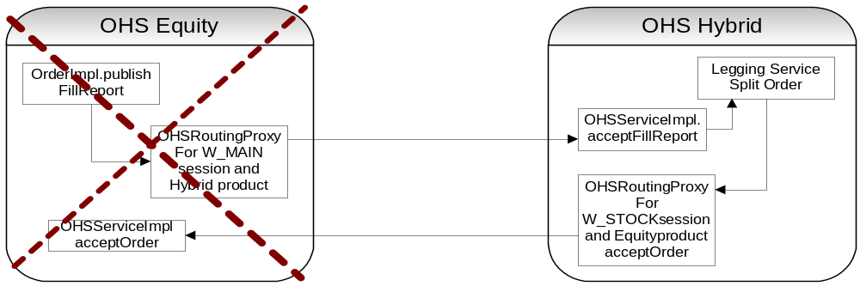
  - If Stock system goes down then spread order should not split and route to PAR.
  - If Stock system auto link the order and goes down then derived order should get cancelled on the recovery
  - If stock system get the fill report but could not apply to Original CPS order then goes down, timeout the CPS order and send message to HD user.
  - After receiving the order from the OHS Hybrid if Stock system goes down then OHS Hybrid should not get the fill report and generate the alert message for HD.

- Hybrid Fail-over
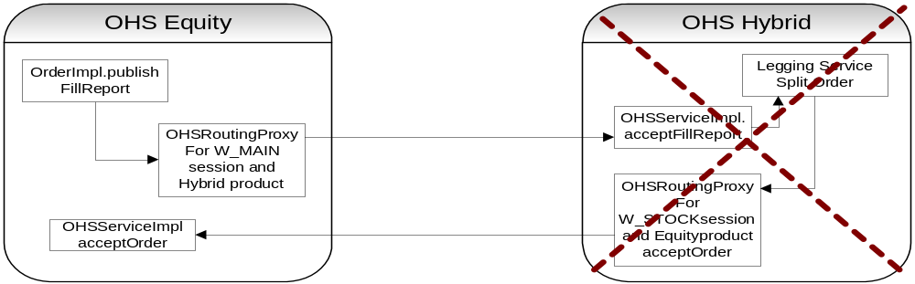
  - Before the legging hybrid goes down then on recovery order should get cancelled.
  - Order is auto link and partially fill, remaining quantity should get cancelled on the recovery.
  - If order is not fill in ratio then on recovery send the timeout message to help desk.

On Fail-over Order Recovery:
When System comes up after the fail-over, on startup we will cancel all the derived orders and as per the spread rule we will cancel spread order.
OrderBookHomeImpl in Trade server is used on startup to create the order books, we will check for the derived order and before booking that order we will cancel it.

HTS Startup:
OrderBookHomeImpl
private void bookOrder(OrderBookImpl book, Order order, boolean holdBDPub, boolean refreshBD)
throws DataValidationException
{
// if it's a cross product order, don't book the order, just
// return the order
if (book.getTradingProduct() != null &&
book.getTradingProduct().isTradableCrossProduct() &&
order.CheckDerivedOrder()) {
order.changeToState(InternalOrderStates.CANCEL);
order.cancelOrder(OrderRoutingReasons.ORDER_REJECTED);
return;
}
order.changeToState(InternalOrderStates.BOOKED);
book.acceptTradable(order, holdBDPub, refreshBD);
}

OHS Startup:
On OHS Server startup, OrderHomeImpl.onGoMaster() method invoked where we load all the active orders from the database in OHS. Once it is loaded then before processing OHS check, which order needs to add in to cache or cancel if it needs to be cancel.
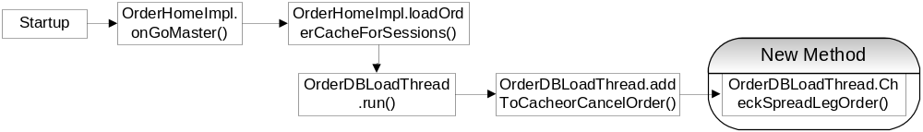

OrderDBLoadThread.addToCahceOrCancelOrder() method, we need to add one check to cancel the spread and/or derived orders.
if (shouldCancelBecauseExpiredProduct(order)
|| ((orderReceivedTime < currentBusinessDayCreateTime) && (order
.getTimeInForce() == TimesInForce.DAY))
|| shouldCancelPAROutboundLinkageOrders(order)
|| shouldCancelActiveAutoLinkedOrders(order)
|| checkSpreadLegOrders(order) )
{
OrdersToBeCancelled.add(order);
threadCancelCount++;
}}

Appendix
- Below table summarizes mapping of the spread order to derived order.

Persistent Field Of an Order | Default values | Populated From
String executingOrGiveUpFirmNumber | null | StrategyOrder.executingOrGiveUpFirmNumber
String executingOrGiveUpFirmExchange | null | StrategyOrder.executingOrGiveUpFirmExchange
String branch | null | Fetch from ID server
int branchSequenceNumber | 0 | Fetch from ID server
String correspondentFirm | null | Populated from either XML/setContext.main
String orderDate // yyyymmdd | null | StrategyOrder.Orderdate
String originatorExchange | null | StrategyOrder.originatorExchange
String originator | null | StrategyOrder.originator
int originalQuantity | 0 | Quantity populated basesd on StrategyOrder.originalQuantity and leg ratio
int productKey | 0 | Fetch product data for leg productkey and populate this column
int classKey | 0
Short productType | 0
Char side
PriceSqlType price | null | StrategyOrder.price
Char timeInForce |  | StrategyOrder.timeInForce
Long expireTime | 0
Short contingencyType | 0 | StrategyOrder.contingencyVolume
PriceSqlType contingencyPrice | null | StrategyOrder.contingencyVolume
int contingencyVolume | 0 | StrategyOrder.contingencyVolume
String cmtaExchange | null | StrategyOrder.ctmaExchange
String cmta | null | StrategyOrder.ctma
String extensions | null | We might want to use the original ordered here
String account | null | StrategyOrder.Account
String subAccount | null | StrategyOrder.subAccount
Char positionEffect | 0 | StrategyOrder.positionEffect
boolean crossingIndicator | FALSE
Char orderOriginType |  | StrategyOrder.orderOriginType
Char coverage |  | StrategyOrder.coverage
String optionalData | null | StrategyOrder.OptionalData
String userId | null | Space/empty
int userKey | 0 | Populated based on userID from UserDataCache service
String userAssignedId | null | StrategyOrder.userAssignedId
String location | null
Short locationType | 0
String previousLocation | null
Short previousLocationType | 0
long receivedTime | 0 | new java.util.Date().getTime()
long bookedTime | 0
int bookedStatus | 0
Short state | 0
int tradedQuantity | 0 | Quantity populated basesd on StrategyOrder.tradedQuantity and leg ratio
int cancelledQuantity | 0 | Quantity populated basesd on StrategyOrder.cancelledQuantity and leg ratio
int bustedQuantity | 0
int cancelRequestedQuantity | 0
int addedQuantity | 0
int bookedQuantity | 0
String orsId | null
char source |  | StrategyOrder.source
char firstTimeOnPar |  | StrategyOrder.firstTimeOnPar
PriceSqlType initialTradePrice | null
Short nbboProtectionType | 0 | StrategyOrder.nbboProtectionType
boolean hadNBBOProtection | FALSE | StrategyOrder.hadNBBOProtection
PriceSqlType effectivePrice | null | StrategyOrder.effectivePrice
boolean nbboProtectionOverriden | FALSE
String instruction | null
OrderImpl crossedOrder | null
int transactionSequenceNumber | 0 | 1
int internalTransactionSequenceNumber | 0
double totalPrice | 0
int totalSessionTradedQuantity | 0
int totalSessionCancelledQuantity | 0
double totalSessionPrice | 0
String[] sessionNames | null | Fetch product data for leg productkey and populate this column
String activeSession | null
int manualSequenceNumber | 0
int totalPendingCancelQuantity | 0
Long cancelledOrderId | 0
Long replacedOrderId | 0
char autobookIndicator |  | StrategyOrder.autobookIndicator
boolean stopOrderTriggered | FALSE | StrategyOrder.stopOrderTriggered
String outboundVendor | null
int shipQuantity | 0
int totalRejectOrTimeoutQuantity = 0 | 0
Short partitionFlag | 0
int parPendingCancelQuantity | 0
boolean orderEverNBBORejected | FALSE

Below Details are used for Derived Order:
LEGG : Correspondent firm reserved for the derived orders.
XLG : Executing Broker Details for Derived orders.
ZLG : For Contra details we can use this details.
999 : This firm will be used as a Contra firm on derived orders.

